Comparison of Various Pathfinder Algorithms' Experimental Performance Using Different Datasets

*By DatPATH*

1. **Introduction**

This report was prepared by DatPath (Yunus, Korel, Büşra) for the course BLG374E Technical Communication for Computer Engineers to show some preliminary results of the project comparison of various pathfinder algorithms’ experimental performance using different datasets. The aim of this preliminary report is to show some of the labyrinths that the pathfinder algorithms will be tested, battery statistics and CPU (Central Processing Unit) info of two computers in which these tests will take place in order to calculate their performance. So far, the project is going as scheduled, however, because of the spring break and midterms we could not meet as we scheduled, so it was compulsory to make shifting’s in the schedule. This report begins with a brief description of the project, a progress summary of what is done so far and new developments of the project.

1. **Project Description**

Pathfinder algorithms help people, generally robots to navigate from their starting point to their destination point. Pathfinder algorithms can be seen in GPS (Global Positioning System) devices, but mostly in robotics. Robots should be able to create the map of the area, to move and find its shortest path to the desired destination. So, pathfinder algorithms should be chosen according to the desired outcomes such as energy consumption, speed and memory which are crucial keys to efficiency. The project’s aim is to compare different pathfinder algorithms: BFS (Breadth First Search), DFS (Depth First Search), Bidirectional, Dijkstra’s, A* and random algorithms. Three different categories of mazes are generated such as crooked maze with one input – one output, flat maze with one input – multiple outputs and crooked roads with one input – multiple outputs. The pathfinder algorithms will be tested on these mazes several times and the efficiency of each will be calculated and presented. The tests will take place in two computers and their performance will be calculated using each system’s preset tools. This project will help designers to choose the suitable algorithm in their projects so that, they will be using the most efficient one and they will have a foresight about the algorithms working process.

1. **Progress Summary**

**3.1.1 Schedules**

|  |  |  |
| --- | --- | --- |
| No: | Work packages | Planned Time (Spring Term 2017) |
| 1 | Creating necessary structures for work environment | 5. Week |
| 2 | Labyrinth Implementation | 6. Week |
| 3 | Testing Tools | 6. Week |
| 4 | Labyrinth Elimination | 7. Week |
| 5 | Implementation of pathfinding algorithms | 9. Week |
| 6 | Experiment 1 | 9. Week |
| 7 | Experiment 2 | 9. Week |
| 8 | Experiment 3 | 9. Week |
| 9 | Data Analysis | 10. Week |
| 10 | Presentation Write-up | 11. Week |
| 11 | Concatenating Experiment Reports | 12. Week |
| 12 | Proofreading | 12. Week |
| 13 | Presentation | 12., 15. Week |

*Figure 1: Planned schedule table.*

|  |  |  |
| --- | --- | --- |
| No: | Work packages | Time (Spring Term 2017) |
| 1 | Creating necessary structures for work environment | 5. Week |
| 2 | Labyrinth Implementation | 6. Week |
| 3 | Testing Tools | 6. Week |
| 4 | Labyrinth Elimination | 7. Week |

*Figure 2: Completed work packages.*

**3.1.2 Work Packages**

Work package 1: Creating necessary structures for work environment:

Status: Completed

* Preparation of the coding environment such as interfaces and constant patterns.

Work package 2: Labyrinth Implementation

Status: Completed

* Implementation of an algorithm that generates random mazes into the project environment.

Work package 3: Testing Tools

Status: Completed

* Testing project environment and maze generation algorithm with Windows Performance Monitor and MacOS Activity Monitor
* Gathering data as CPU usage, energy cost and memory usage.

Work package 4: Labyrinth Elimination

Status: Completed

* Generating different mazes and eliminating the ones which does not fit to the specifications.

Work package 5: Implementation of pathfinding algorithms

Status: Planned

* Implementation of all the pathfinding algorithms (BFS, DFS, Bidirectional, Dijkstra’s and A* algorithms)

Work package 6: Experiment 1

Status: Planned

* Testing crooked mazes with one input – multiple outputs by the pathfinding algorithms (BFS, DFS, Bidirectional, Dijkstra’s and A* algorithms)
* Gathering data according to the tests such as efficiency, power consumption, memory status and time.

Work package 7: Experiment 2

Status: Planned

* Testing flat mazes with one input – one output will be done by the pathfinding algorithms (BFS, DFS, Bidirectional, Dijkstra’s and A* algorithms)
* Gathering data according to the tests such as efficiency, power consumption, memory status and time.

Work package 8: Experiment 3

Status: Planned

* Testing mazes with (crooked roads and long corridors) with one input – multiple outputs by the pathfinding algorithms (BFS, DFS, Bidirectional, Dijkstra’s and A* algorithms)

Work package 9: Data Analysis

Status: Planned

* Analyzing data and creating charts according to the efficiency, power consumption, time and memory usage.

Work package 10: Presentation Write-up

Status: Planned

* Writing the experiment reports

Work package 11: Concatenating Experiment Reports

Status: Planned

* Gathering all the reports in addition to their concatenation
* Preparing the final presentation

Work package 12: Proofreading

Status: Planned

* Proofreading the prepared presentation for the prevention of statistical errors.
* Correction of the mistakes to finalize the presentation.

Work package 13: Presentation

Status: Planned

* Presenting all the experiment.

**4. New Developments**

**4.1 Problems Encountered**

Due to midterms and spring break, we had some problems arranging meetings: some planned meetings could not take place in which caused some delay completing the planned work. We had to edit some mazes by hand since the outputs did not fit to our needs.

**4.2 Changes in Requirements**

The mazes are created with the size of 50 x 50 instead of 100 x 100 since it is difficult to analyze the matrix in full-screen.

**4.3 Preliminary Results**

In work packages section, after the implementation of the random labyrinth generator algorithm we run it many times and eliminated the unwanted ones in which in our project we want labyrinths in three different types which are: crooked maze with one input – one output, flat maze with one input – multiple outputs and crooked roads with one input – multiple outputs. For each category, we chose 10 in order to compare their statistical data in which they will be in our final report. Here are some of the mazes:

**First Category: Crooked Maze with One Input – One Output**

 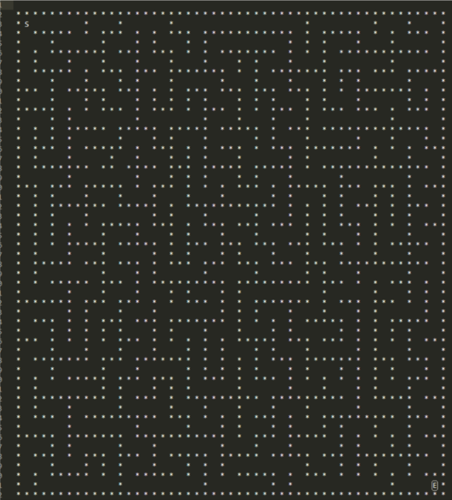

*Maze 1.1 Maze 1.2*

**Second Category: Flat Maze with One Input – Multiple Outputs**

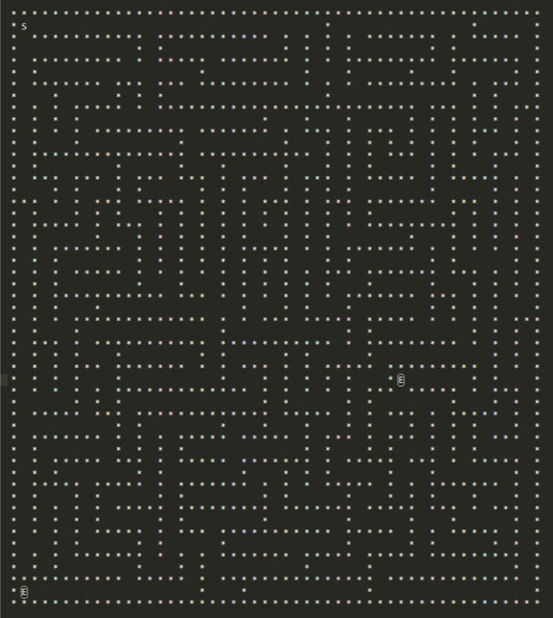 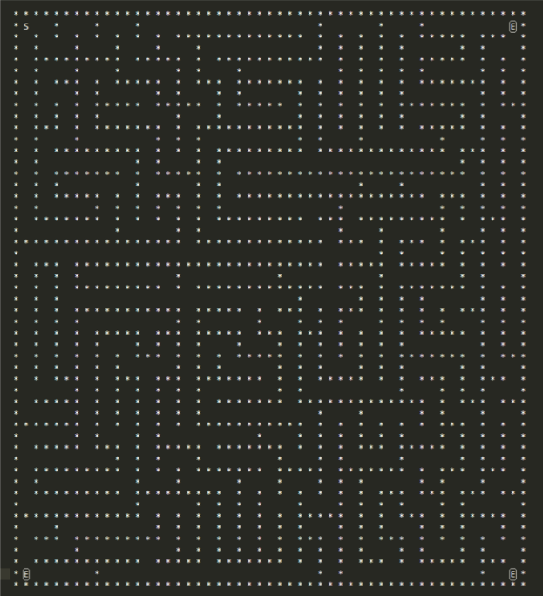

*Maze 2.1 Maze 2.2*

**Third Category: Crooked Maze with One Input – Multiple Outputs**

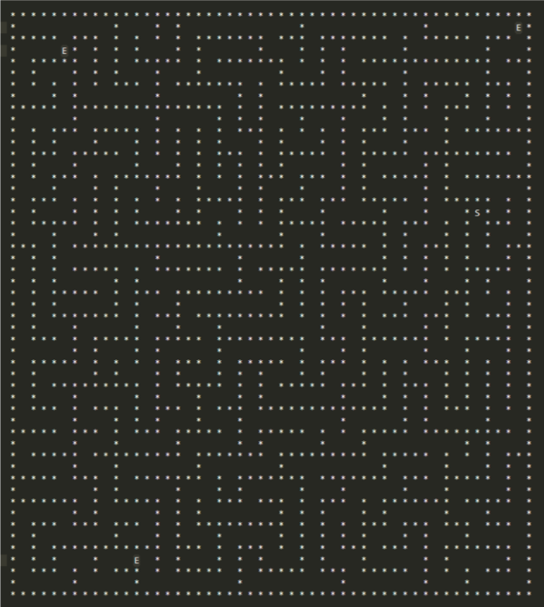 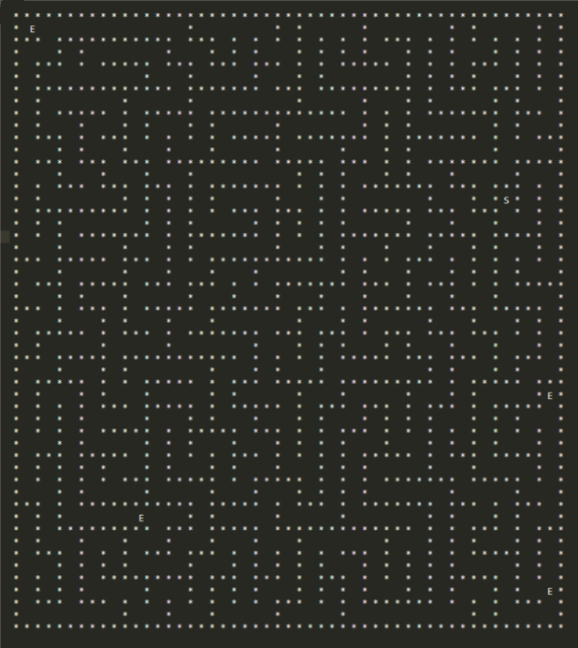

*Maze 3.1 Maze 3.2*

**A table of the statistics of the computers that the pathfinder algorithms will be tested**

|  |  |  |  |  |  |  |
| --- | --- | --- | --- | --- | --- | --- |
| Computer / Model | CPU info | Max. Battery Cap. | Cur. Battery Cap. | Cur.  Battery Health | *Battery Consumption in ≈1 min. | **Battery  Cycle |
| Apple MacBook Pro (Mid 2015) | 2,8 GHz Intel Core i7 4980HQ  L1: 32KB/32KB  L2: 256KB  L3: 6MB | 8,755 mAh | 8,095 mAh | ≈92% | Avg. ≈14,2 mAh | 228 |
| Asus n  n550jk cn167d | 2,4 GHz Intel Core I7 4700HQ  L1: 256KB  L2:1024KB  L3:6MB | 4000 mAh | 2841.9594  mAh | ≈71% | Avg. ≈32 | No data |

*All the statistics for MacBook are gathered from* ***Battery Monitor*** *and for Asus from* ***BatteryViewInfo*** *programs.*

**\* Battery Consumption in ≈1 minute:** The battery consumption with the default programs running in the OS (Operation System). In addition to that, mouse was plugged in, wi-fi was on and the screen brightness was full in order to get a standard consumption average. It was calculated right after a reboot several times to get the average.

**\*\* Battery Cycle:** The charge / discharge cycle in which shows the battery life.

**Note:** Since it is difficult to measure the exact amount of battery consumption the battery consumption in 1 minute is an approximate value. Additional tools are needed to calculate the nearly to get the exact amount in which it will be also variable according to the health condition of the battery, weather (temperature), environment, running OS (Operation System) processes and etc. Also, the battery health is variable too.

**4.4 Assessment of Progress**

Despite of some encountered problems, this project has a good start: outputs of mazes obtained are sufficient for the path finding algorithms, but it is not hard to say that the improvement of this project is not quite fast due to other responsibility of group members: It would give more pleasure if there was more time.